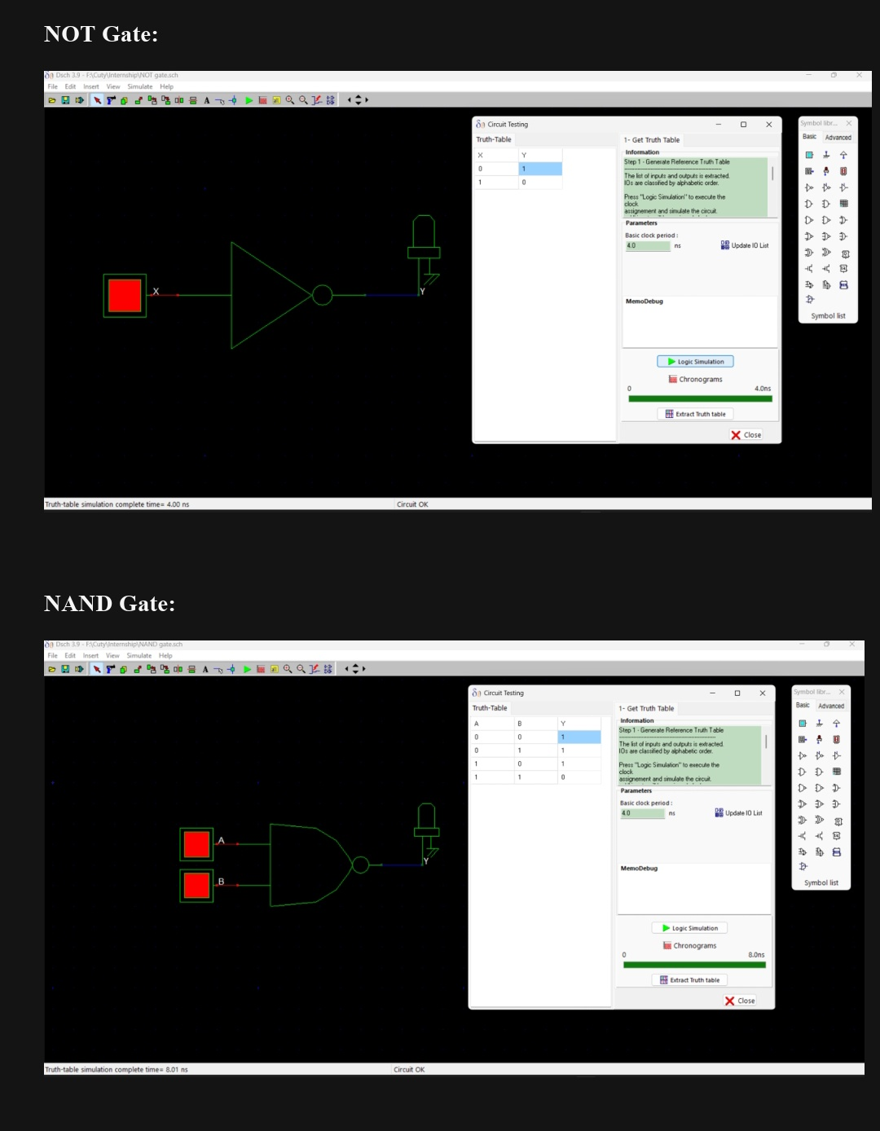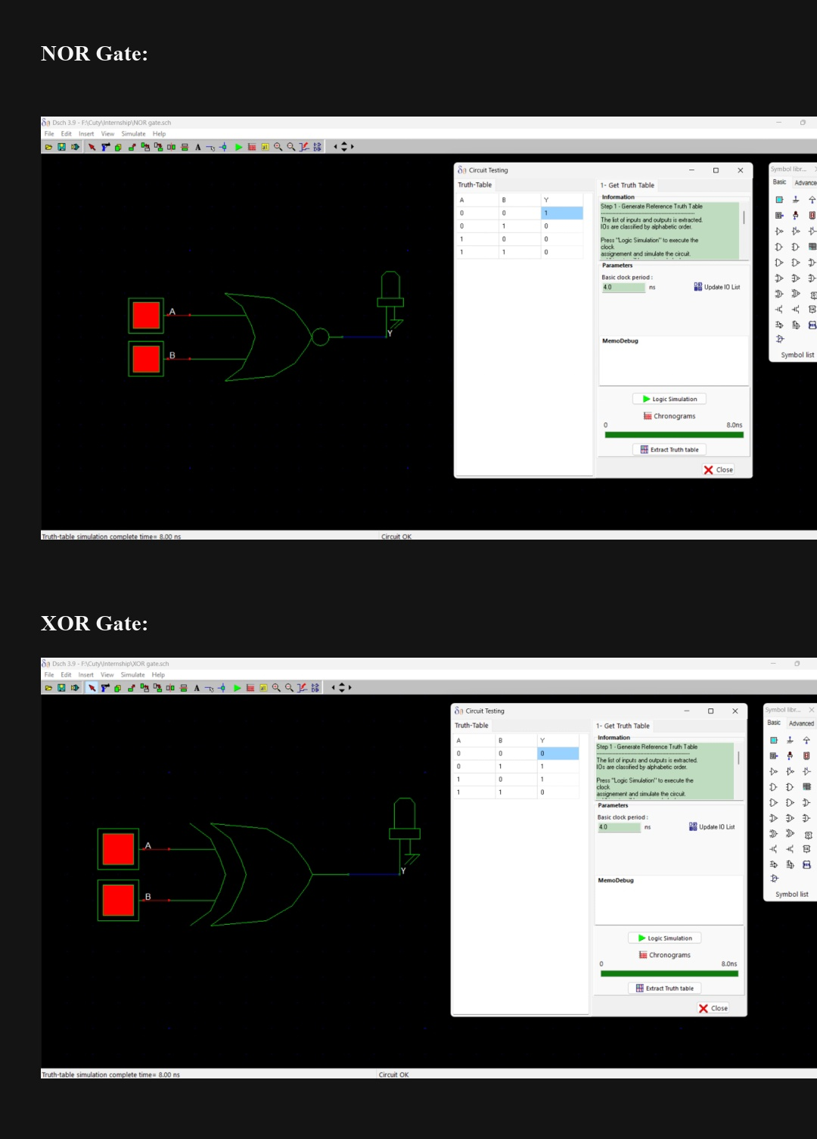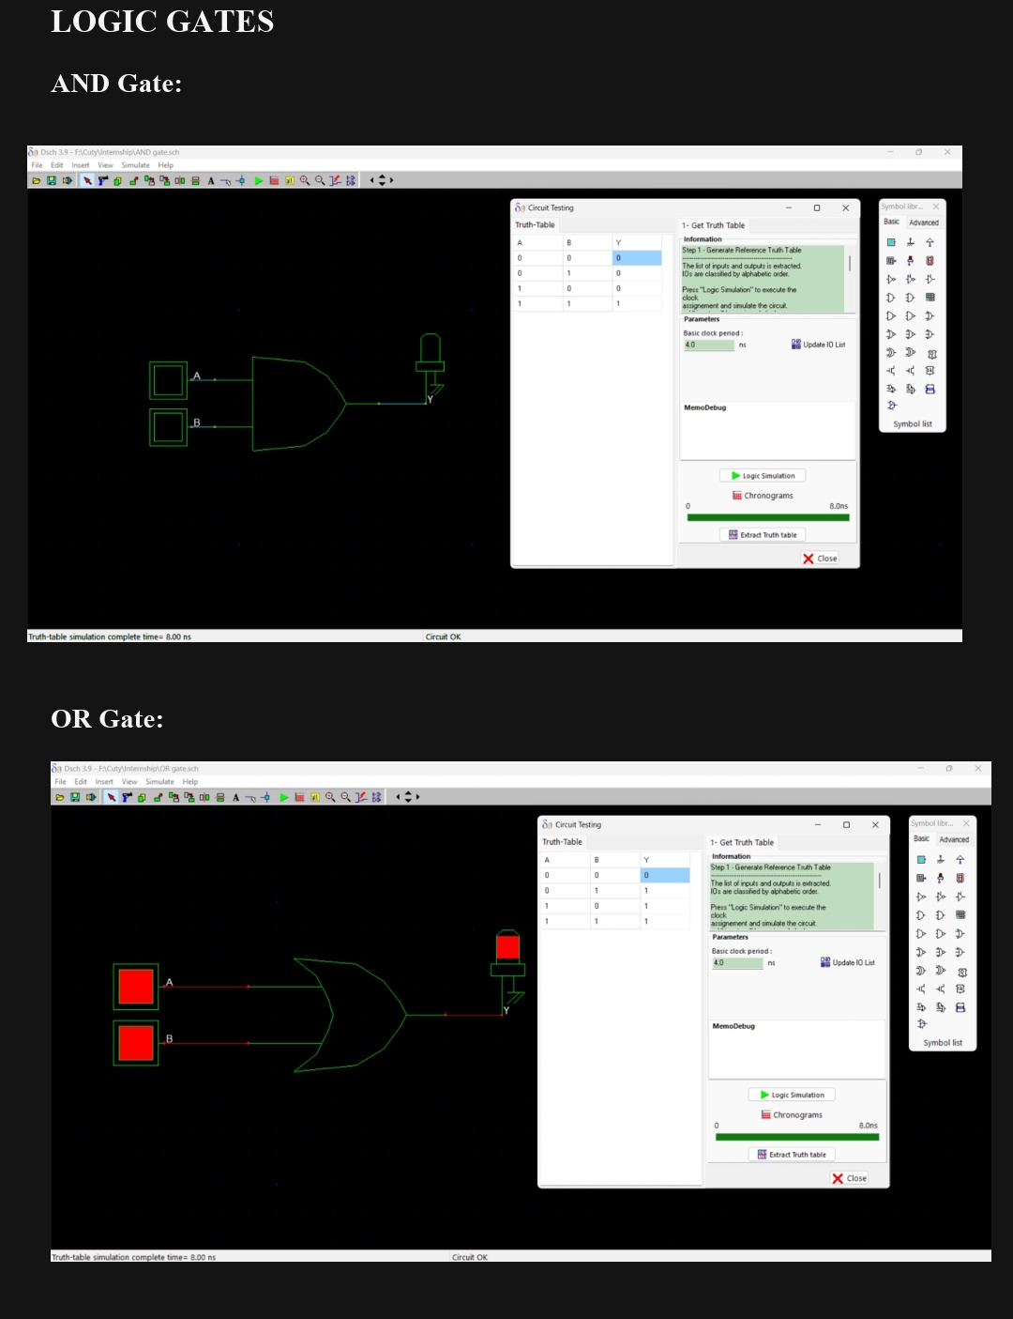

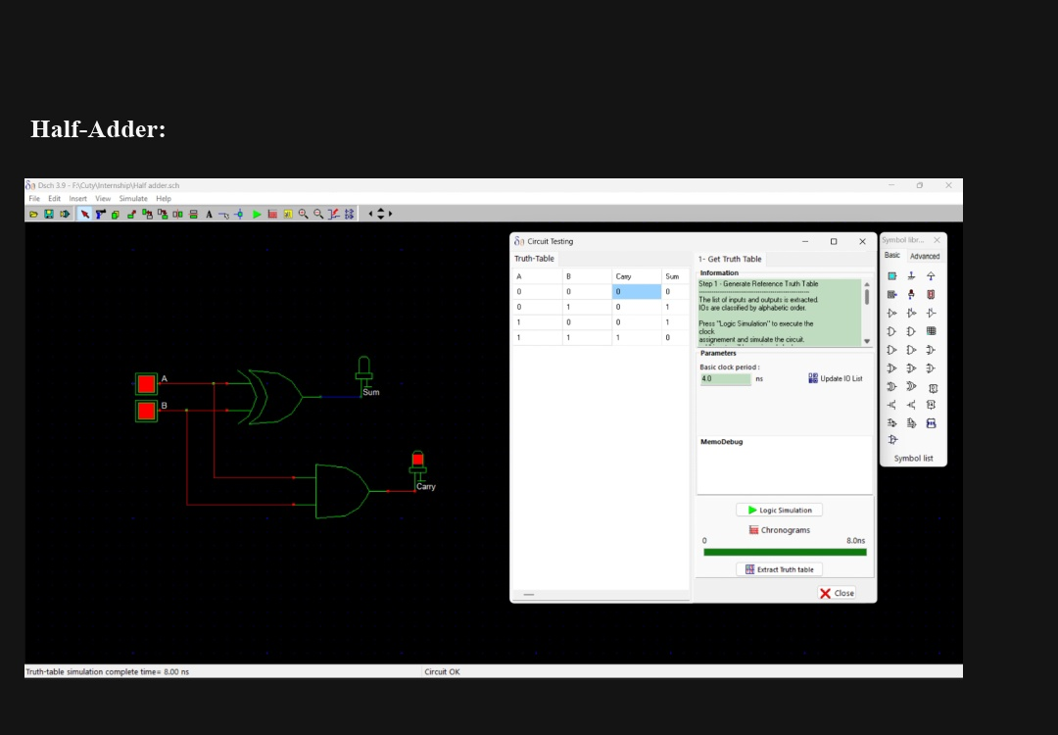

VLSI Design Flow Explanation
The standard industry VLSI design flow involves several critical steps to move from an initial idea to a physical chip:
- System Specification: Defining the chip's purpose and its constraints regarding power, performance, and area.
- Architecture Design: Creating high-level block diagrams to show data flow and functional blocks.
- RTL (Register Transfer Level) Design: Coding the design using Hardware Description Languages like Verilog or VHDL.
- Functional Verification: Testing the RTL code through simulation to ensure it works correctly.
- Synthesis: Converting the verified RTL code into a gate-level netlist.
- Physical Design: Performing floorplanning, placement, and routing of the actual components.
- Timing & Power Analysis: Verifying that the design meets speed and power targets.
- Fabrication: The actual manufacturing of the silicon chip.
- Testing & Validation: Checking the final manufactured chips for defects.

Logic Gate Truth Tables
Gate | Input A | Input B | Output
AND | 0 | 0 | 0
 | 0 | 1 | 0
 | 1 | 0 | 0
 | 1 | 1 | 1
OR | 0 | 0 | 0
 | 0 | 1 | 1
 | 1 | 0 | 1
 | 1 | 1 | 1
NAND | 0 | 0 | 1
 | 0 | 1 | 1
 | 1 | 0 | 1
 | 1 | 1 | 0
NOR | 0 | 0 | 1
 | 0 | 1 | 0
 | 1 | 0 | 0
 | 1 | 1 | 0
XOR | 0 | 0 | 0
 | 0 | 1 | 1
 | 1 | 0 | 1
 | 1 | 1 | 0
NOT Gate
Input A | Output
0 | 1
1 | 0

Half Adder
Input A | Input B | Sum (A ⊕ B) | Carry (A AND B)
0 | 0 | 0 | 0
0 | 1 | 1 | 0
1 | 0 | 1 | 0
1 | 1 | 0 | 1

3. Observations from Simulation
- Inputs Used: List the specific combinations of logic 0 and logic 1 applied to the circuits during testing.
- Output Behavior: Document how the circuit responded and verify if the outputs matched the expected truth tables.
- Mistakes and Corrections: Note any errors encountered during the design or simulation and the steps taken to fix them.

